
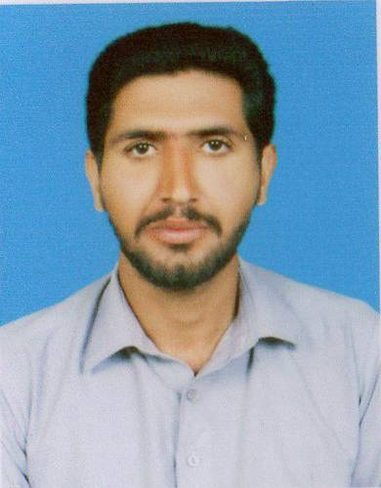

uzair hafeez
Cell # 00973-34118684
Personal Information:

Name: UZAIR HAFEEZ
Father Name: HAFEEZ-UR-REHMAN.
Present Address: Road 4347 Build 1565 Flat 23 Sanad Bahrain.
Mobile: 00973-34118684
E-mail: Uzair.hafeez123@gmail.com
Date of Birth: 21-08-1992
Marital Status: Single
CPR NO 920847501
Domicile: Jhelum
Religious: Islam
Nationality: Pakistani
Languages:
- Urdu
- Punjabi

MATRIC | GOVERNMENT SECONDARY SCHOOL. | 2008-2010 | 3rd division.
Academic Qualification Record

NO | Experience Duration | Designation | Institution/Company
01 | 3 year | GUARD. | RAWAL LAKE.
02 | 3year | GUARD. | GHARIBWAL CEMENT FACTORY.
Working Experience:

Reference

- Reference will be provided on demand

